**Project 2 Part 2 (square with min area)**

Name: ______________Michael Fatemi______________

Date: ______________10/23/2020__________

Is your lab name l022?(lowercase L followed by digits 022) _____Yes______

Did you comment out the call to part1 method? _____Yes______

Did you create a class for a Point? _____Yes______

Did you create a class for a Line? _____Yes______

List all classes you created in this project: Point, Line, LineSegment, Polygon, Image

Did you use the precision for the points like in the sample? _____Yes______

Did you test your file on a school computer using ssh? _____Yes______

Did your file compile and run on school computer? _____Yes______

Paste here **2 sets of clear picture/content** of the points.txt, output.txt and output.ppm you created when running 2 times your lab :

* one of the runs should be on the sample provided by Mr. Jurj;

points.txt: (0.18161564989165929,0.49650563066499831) , (0.20331431012909329,0.66115298928800315) , (0.45457319864497819,0.36802270577105012) , (0.86330759605700857,0.82033753471480453)

output.txt: (0.18161564989165929,0.49650563066499831) , (0.20331431012909329,0.66115298928800315) , (0.45457319864497819,0.36802270577105012) , (0.86330759605700857,0.82033753471480453)

(0.44965933148143983,0.35848004700834973) , (0.52122072857609081,0.49745124226642912) , (0.66019192383417014,0.42588984517177819) , (0.58863052673951921,0.28691864991369881) Area = 0.024434026665597547

(0.21626596678621329,0.65838060894706696) , (0.50356215373881785,0.59688312473948146) , (0.56505963794640346,0.88417931169208608) , (0.27776345099379884,0.94567679589967157) Area = 0.086321039601368138

(0.23229804918860969,0.50597175896598379) , (0.19683240149944256,0.69585764053809274) , (0.38671828307155148,0.73132328822725978) , (0.42218393076071864,0.54143740665515094) Area = 0.037314460186429116

(0.34174493950384799,0.28328741002475732) , (0.43467909320732451,0.35308200810630164) , (0.36488449512578019,0.44601616180977816) , (0.27195034142230368,0.37622156372823384) Area = 0.013508042845945705

(0.11723405021564343,0.61397476973488152) , (0.27298780221724167,0.69933911128708115) , (0.35835214376944136,0.54358535928548291) , (0.20259839176784314,0.45822101773328322) Area = 0.031546302071215969

(0.26976728773113051,0.54851018465181811) , (0.30404636140174307,0.49040457166165108) , (0.36215197439190994,0.52468364533226364) , (0.32787290072129738,0.58278925832243056) Area = 0.0045513171526783518

output.ppm:

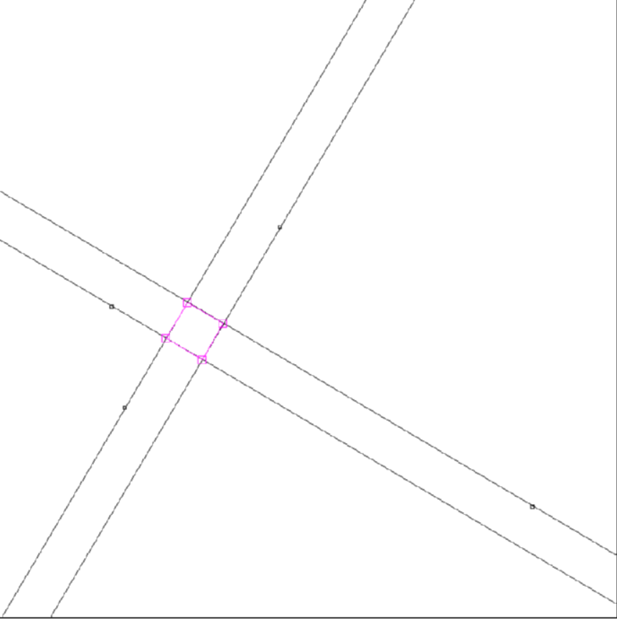

* the other run on a random set of points.txt your part1 generated!! :

points.txt:

(0.1672719504379406,0.26294747764519183) , (0.37858211004974518,0.033845027008880889) , (0.50770592364268929,0.96185186315500348) , (0.26834925382244329,0.03933835871456038)

output.txt:

(0.1672719504379406,0.26294747764519183) , (0.37858211004974518,0.033845027008880889) , (0.50770592364268929,0.96185186315500348) , (0.26834925382244329,0.03933835871456038)

(0.49756037126736513,0.25818533769502505) , (0.49430174841092789,0.032176566723549731) , (0.26829297743945252,0.035435189579987064) , (0.27155160029588987,0.26144396055146241) Area = 0.051090583178957281

(0.12047590255728471,0.18070155804883906) , (0.077244708997065925,0.20529911879970231) , (0.052647148246202646,0.16206792523948346) , (0.095878341806421435,0.13747036448862018) Area = 0.0024739760915335105

(0.42663799891777926,0.17404614940290314) , (0.3686777233775172,0.0049493773646925344) , (0.19958095133930659,0.062909652904954622) , (0.25754122687956871,0.23200642494316526) Area = 0.031953111854445673

(0.2114071251767447,0.24471225660081625) , (0.1613643188970405,0.12359236481556737) , (0.28248421068228935,0.073549558535863202) , (0.33252701696199349,0.19466945032111205) Area = 0.017174310646418396

(0.11711521693729626,0.14562895313680332) , (0.15231545994392992,0.1305799298470891) , (0.13726643665421578,0.095379686840455544) , (0.10206619364758211,0.11042871013016975) Area = 0.0014655302097004224

(0.35001892835959303,0.28382822180098738) , (0.37654193657607682,0.051700498728040202) , (0.60866965964902386,0.078223506944523971) , (0.58214665143254019,0.31035123001747111) Area = 0.054586749783882525

output.ppm:

